**DAILY ONLINE ACTIVITIES SUMMARY**

|  |  |  |  |  |  |  |  |  |
| --- | --- | --- | --- | --- | --- | --- | --- | --- |
| **Date:** | **25-05-2020** | | | | | **Name:** | **Raksha S** | |
| **Sem & Sec** | **6th B** | | | | | **USN:** | **4AL17CS073** | |
| **Online Test Summary** | | | | | | | | |
| **Subject** | |  | | | | | | |
| **Max. Marks** | |  | | **Score** | | |  | |
| **Certification Course Summary** | | | | | | | | |
| **Course** | **Cyber security specialization**  **Machine learning with python** | | | | | | | |
| **Certificate Provider** | | | **Udemy**  **cognitive** | | **Duration** | | | **8hrs** |
| **Coding Challenges** | | | | | | | | |
|  | | | | | | | | |
|  | | | | | | | | |
| **Uploaded the report in Github** | | | | | **YES** | | | |
| **If yes Repository name** | | | | | **https://github.com/raksha05/**[Daily-Status](https://github.com/raksha05/Daily-Status)/[Raksha 4AL17CS073](https://github.com/raksha05/Daily-Status/tree/master/Raksha%204AL17CS073)/**Raksha** | | | |
| **Uploaded the report in slack** | | | | | **YES** | | | |

Certification Course Details:

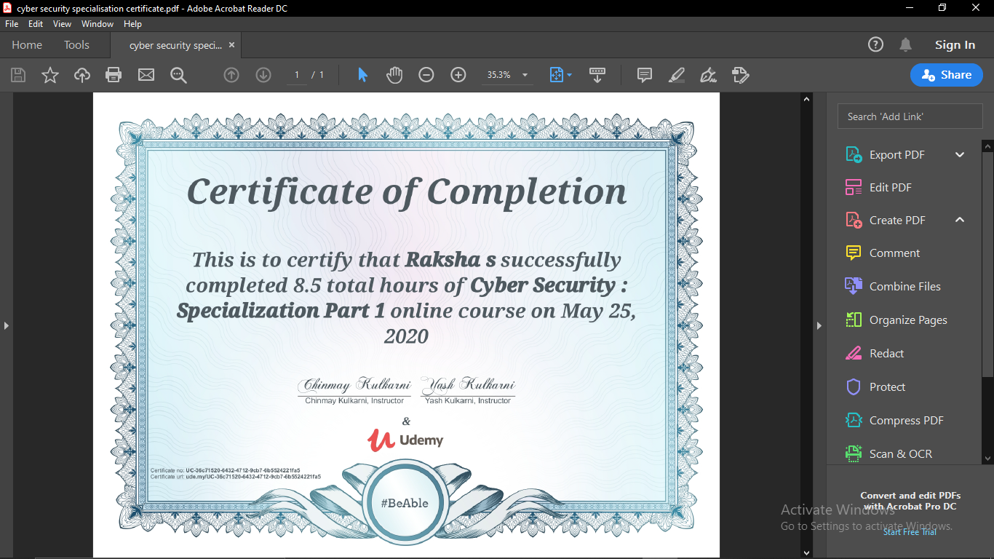

The above course is being taken up by me is based on CyberSecurity. And successfully completed the course.And assignments were given based on the key concepts on security,

